Final Exam: JAVASCRIPT FRONT

WEP 2023

{3h 00}

04 Feb 2022

* All documents allowed
* Chatting and talking to other students is forbidden
* Don’t change any **CODE** in **HTML** & **CSS**

|  |  |
| --- | --- |
| EXERCICES | POINT |
| Exercise 1 | 25 |
| Exercise 2 | 25 |
| Exercise 3 | 25 |
| Exercise 4 | 25 |
| **TOTAL** | **100** |

# EXERCISE 01 - 25pt

In the JS file, **add a card to the body** containing *(see JS file for further information*):

* Title
* Image
* Paragraph
* Anchor tag link to this link: "https://www.w3schools.com/”

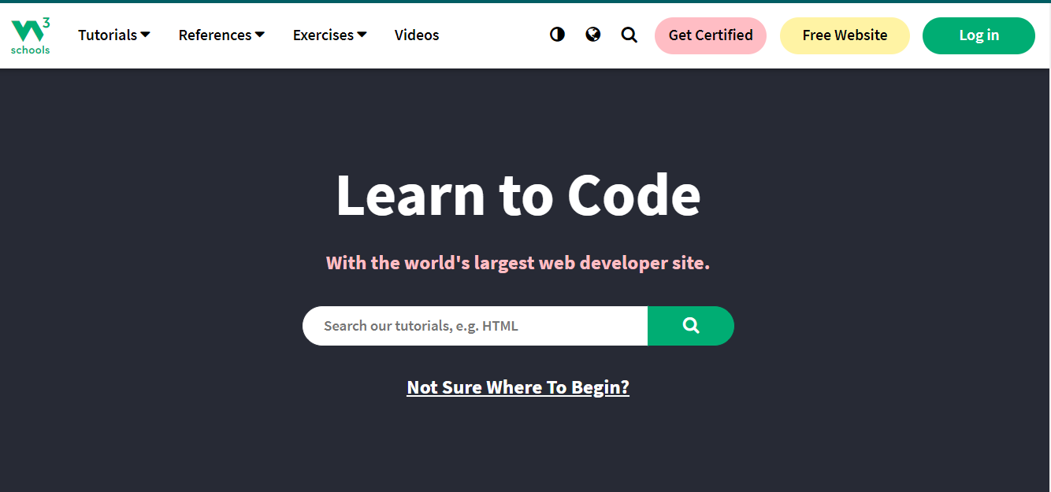

# EXERCISE 02 - 25pt

We want to display a list of persons, and some detailed information about each person.

**Q1** Display the **list of persons** as shown below, using the data structure already defined in the JS file

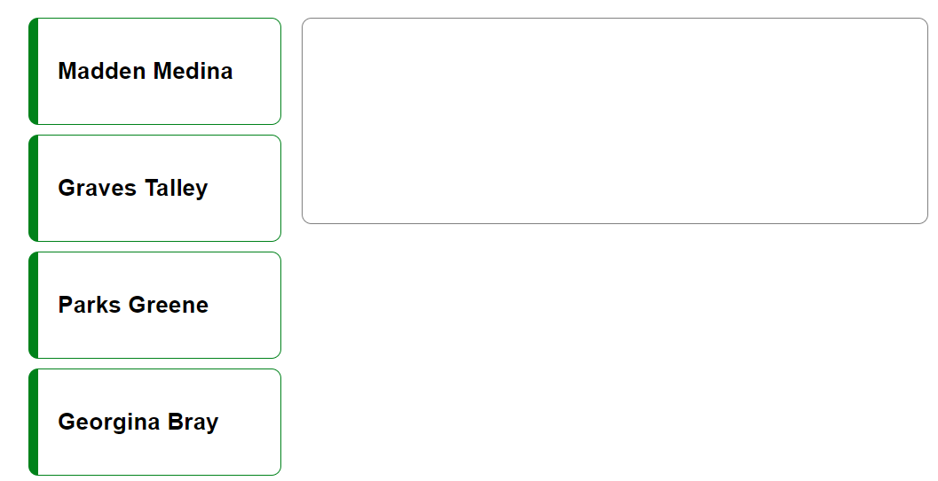

**Q2** When clicking on a person, display the **detailed information** about this person, as shown below

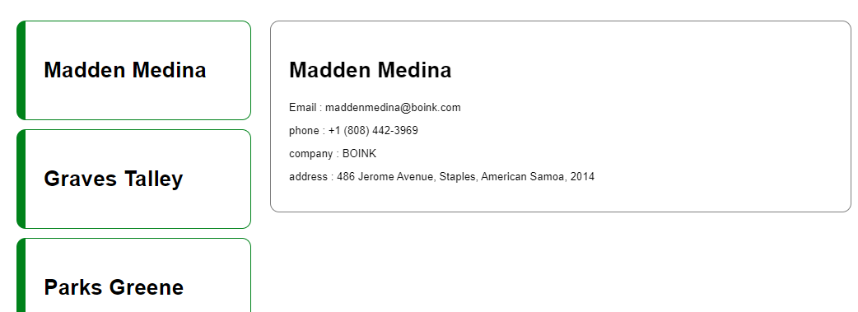

Click here

# EXERCISE 03 - 25pt

Calculate the two numbers following the operator below

1. Subtraction
2. Division
3. Average

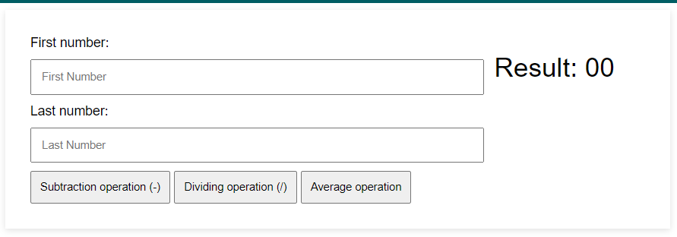

# EXERCISE 04 - 25pt

We want to **manage students’ profiles**

Each student has the following information:

* Student name
* Student gender
* Student favorite sports
* A Quote from the Student

When clicking on **ADD STUDENT**, a new card shall be created on the right side, as follow:

* When user choose gender as “**MALE**”, display the student’s name with “**Mr.**” and set the card’s border color to “**GREEN**”
* When user choose gender as “**FEMALE**”, display student’s name with “**Ms.**” and set the card’s border color to “**ORANGE**”

